PWA video 11 audit in lighthouse

<https://www.youtube.com/watch?v=egmwY9n6qWY>

lighthouse plug in

checklist of required items to make an app a progressive

In the console go to Audits> in my case Lighthouse

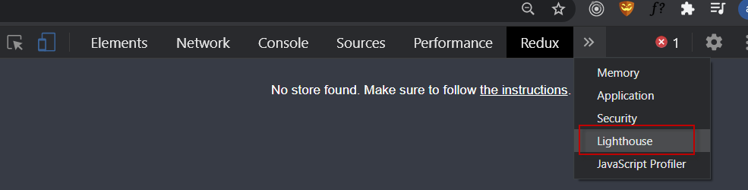

Check progressive web app

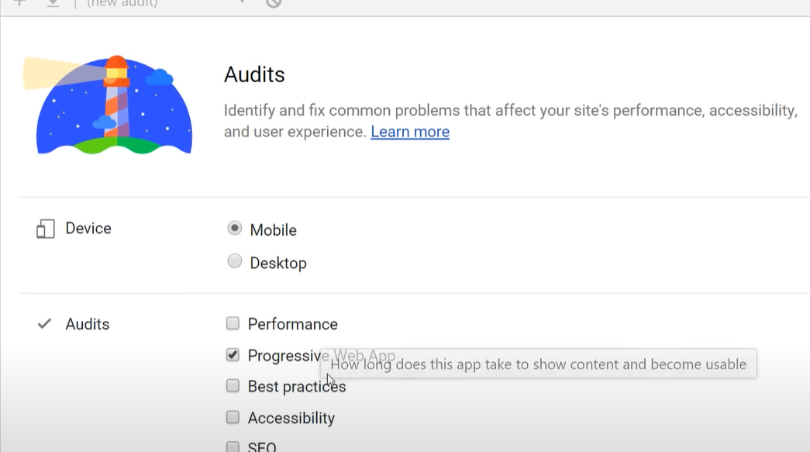



add to home screen NEED TO MEET CRITERIA 